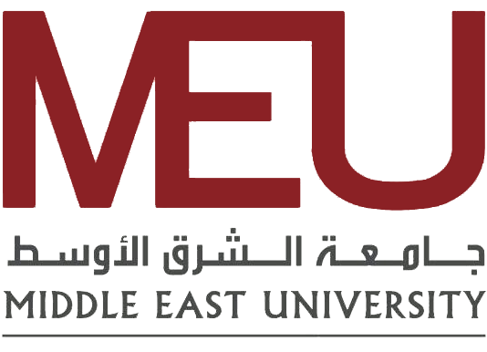

**FDRS(Free Distribution resource system)**

**Team members**

**Anas Alseid**

**Wasef Jayousi**

**Saif Karborani**

**Supervisor:**

**Ashraf Odeh**

**Undergraduate Project Proposal**

Group No. (2)

Monday 20th November, 2023

# 1 ) Problem Statement

The problem is "That we don’t have a Free distribution resource system that will solve the problem we have ”

# 2) Objectives

## 1 . Design an advanced search functionality that allows users to find resources based on specific criteria such as subject, course, author, or publication date.

## 2 .Implement a system that enables users to easily share and upload their academic resources, fostering a collaborative educational environment.

## 3 .To have and up-to-date database that caters the user needs.

## 4 .To develop and design an application that is lightweight ,compatible with a wide variety of devices and a user-friendly interface.

## 5 .To validate and test all aspects of the designing and the development processes.

# 3) Scope

## Project Name:

## Free Distribution resource system (FDRS)

## Project Description:

## The project objective is to build an all-encompassing, free distribution resource system which would enable students to both share and acquire student materials. By so doing the educational experience of the individual student can be enriched.

## Objectives :

## Advanced Search Functionality:

## Development of a search engine for filtering resources on the basis of subject, course title, author name or publication date.

## Resource Sharing Mechanism:

## Establishment of a user-friendly network for the uploading and sharing of academic materials such as notes, articles, videos.

## Database Development:

## Establishment of a flexible, current database which can satisfy the increasingly specialized and sophisticated academic needs of users.

## Application Development:

## Design and develop a lightweight Website that fits as many devices as possible, emphasizing usability, user friendliness.

## User Interface and Experience:

## Designing an easy-to-use, interactive user interface that streamlines navigation and resource retrieval.

## Testing and Validation:

## Creating comprehensive testing and validation processes to ensure functionality, reliability, and user satisfaction.

## Limitations:

## Paid Resources:

## The platform will not include paid or subscription-based academic resources.

## Non-Academic Content:

## The scope limited to academic resources, so as not to include non-educational content such as general entertainment or news.

## 24/7 Support:

## Because of limited resources, immediate or round-the-clock technical support is not guaranteed.

## Comprehensive Academic Coverage:

## With a goal of covering many subjects on the table, at first there may not be all academic disciplines or specialized areas.

## Resource Quality Control:

## But, though the platform will provide a medium for sharing resources, assuring quality and accuracy of user-uploaded content is going to be difficult.

## Language Constraints:

## At first, the platform may only be available in English, making it difficult for non-English speakers to use.

# Assumptions:

## * User Engagement:

## Based on active involvement by students and teachers in sharing resources.

## Technical Compatibility:

## Unless users have the devices and internet access to support the Website.

## Dependencies:

## User Contribution:

## For the platform to succeed, users have got to contribute in sharing resources and feedback.

## Technical Infrastructure:

## They rely on robust server and hosting solutions to handle the database as well as user traffic.

# 4) Methodology

In developing the FDRS, we will adhere to the Waterfall methodology. This traditional approach to software development is characterized by its linear and sequential phases, each building upon the completion of the previous one. This method offers clear milestones and well-defined objectives at each stage, ensuring a systematic and disciplined progression of the project.

The rationale behind choosing the Waterfall methodology for FDRS lies in its simplicity and structured framework. It allows for a clear understanding of project milestones and deliverables, making it easier to manage and evaluate progress. This methodology is particularly effective in projects with well-defined requirements and objectives, such as FDRS.

Using the Waterfall methodology, we will systematically develop the FDRS, ensuring each phase is completed with thoroughness and precision. This approach will help us create a robust, user-friendly, and effective resource distribution system that aligns with our project's goals and objectives.

# 5) Significance

The most important aspect of our project is its transformative value in enriching the students 'educational experience. We hope to give every new student on his or her journey of education, a share in each other's personal experiences and effective learning strategies. Through this exchange of knowledge and insights between international scholars, there is a map which can lead students not only to reach their academic ends but also soar beyond them.

Our initiative understands that students face different challenges and learning curves in different subjects. With access to the first-hand accounts and proven methods culled from their peers who've already gone through these trials, we are providing a very useful tool. It is peer-to-peer guidance designed for the actual academic environment. Practical and implementable, it can often be lacking from traditional educational resources.

Furthermore, this project extends beyond the typical range of educational materials in encouraging a network of learners. It fosters a place where there is shared success and students feel inspired by the achievements of those around them. This sense of community is part and parcel to our vision. It creates an environment where students are not only the pursuit of their own excellence, but also looking outward toward shared success for all around them.

Basically, our project is significant in that it not only has the potential to help students improve their individual academic performances but also might allow us all together to build an education environment of free give and take. With shared experiences and stories of success, we hope to establish a new standard for academic support centres as well. At our place every child can find the needed resources to become successful in his or her scholastic life.

# 6) Deliverables

## User friendly interface

## User history of downloads list

## User login page

## User can upload documents under his name

## User can review , rate , different documents that got uploaded to the website